THE INSPECTION PROCESS
The full article of the RMVR “Legal & Proud” process is linked here: http://www.channelbeemer.net/lffr_web/LnP.htm
Below is an excerpt fron that article with relevant inspection steps.
The inspection process consists of eight steps.
STEP ONE is a visual check of the value train, carburetor, intake manifold, and flywheel for correctness. Formula Fords can be run with either a "Cortina" configuration motor or an "Uprated" unit, and the appropriate declaration is made at that time. "Uprated" head is flush, the uprated pistons have cast reliefs to provide valve clearance. Aftermarket high-compression pistons can usually be detected visually, but stock units modified for higher compression are common; measuring the bowl depth and diameter will identify those pistons.
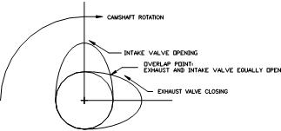  Figure 1 |  | STEP TWO in the inspection process is a measure of the overlap of the intake and exhaust valves to verify that the camshaft is proper. Figure #1 shows a typical pair of cam lobes. As can be seen, there is a point at which the intake and exhaust valves will be at equal lift at the "overlap" (exhaust valve nearly closed and intake valve just starting to open). If the duration of the lobe is increased, the total lift (intake + exhaust) at the overlap point will also increase. Based on numerous samples of stock Formula Ford cams, it has been determined that, at the point where the intake and exhaust valves are at equal lift, the lift is approximately 0.052" on each valve, or .104" total. If the sum of the two lifts substantially exceeds this amount, the cam is considered illegal. Figure #2 shows the L&P inspection fixture holding two dial indicators to obtain these readings; this could also be accomplished with two magnetic bases holding the dial indicators.
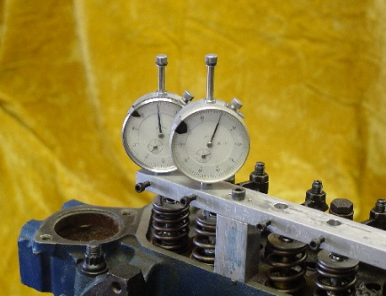
Figure 2

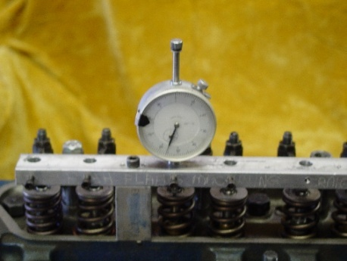  Figure 3 | STEP THREE measures the maximum valve lift for each intake and exhaust valve. SCCA/GCR regulations state that the maximum exhaust valve lift is 0.358" and the maximum intake valve lift is 0.356", measured with the lash adjusted to zero. The L&P fixture is used again to check the valve lifts as shown in Figure #3. If the valve lifts are in Spec, the head is removed.

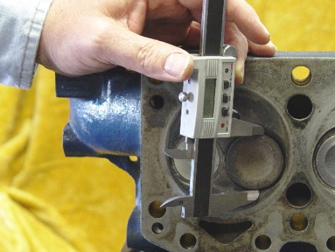  Figure 4 | STEP FOUR is the check of the intake and exhaust valve diameters, and verification of the combustion chamber depth. The engine configuration ('Cortina' or 'Uprated') is determined by the type of cylinder head in use. When the head is removed, it is first checked for its applicability to eithe "Cortina" or the "Uprated" declaration. Next, the valves sizes are checked for their applicability to the declared engine. Figure #4 shows an intake valve diameter being measured. If the head is a "Cortina," the depth of the combustion chamber is checked for minimum depth to verify compliance to the compression ratio limitation.

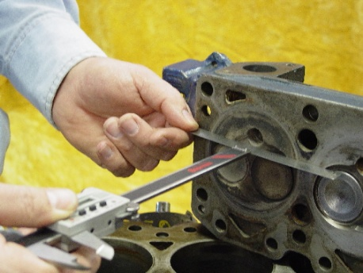  Figure 5 | Figure #5 shows the check of the combustion chamber on a "Cortina" head using a dial caliper; a depth micrometer is preferable, if available. "Uprated" heads are flush (i.e., do not have a combustion chamber).

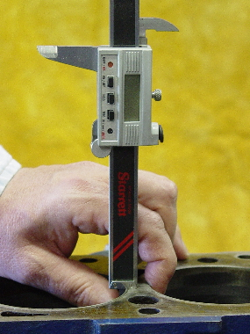  Figure 6 | STEP FIVE is a check of the engine's stroke, which is specified as 3.060" maximum for both the "Cortina" and the "Uprated" engines. A dial caliper can be used to check the stroke as shown in Figure #6, but a depth micrometer is more accurate.

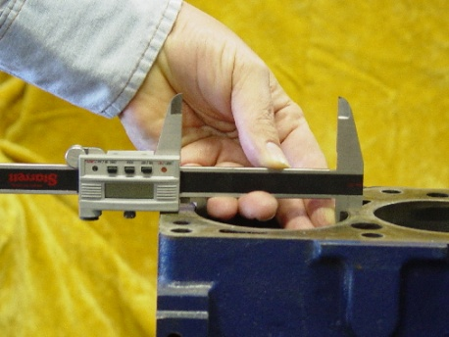  Figure 7 | STEP SIX is a check of the cylinder bore. The maximum piston diameters for the "Cortina" and "Updated" engines differ; the "Cortina" engine is permitted up to 3.218" diameter pistons (+.030"), while the "Uprated" engine can use only "standard" 3.188" diameter. Since we can't actually measure the piston diameter, we measure the cylinder bore and subtract .0 10". Figure #7 shows the dial caliper used to verify the cylinder bore.
STEP SEVEN is a check of the pistons. Since the pistons designs are different for the "Cortina" and "Uprated" engines, it is necessary to verify the depth and diameter of the bowl, as well as the correct application of pistons. Because the "Uprated" head is flush, the uprated pistons have cast reliefs to provide valve clearance. Aftermarket high-compresstio pistons can usually be detected visually, but stock units modified higher compression are common; measuring the bowl depth and diameter will identify those pistons.
STEP EIGHT is a check of engine deck height, the distance between the top of the piston and the top block; this dimension generally controls the compression ratio. In the "Cortina" engine, the piston is allowed to be 0.006" (max) above block deck while, for the "Uprated" engine, the piston should be approximately 0.026" (min) below deck. These dimensions correspond mathematically to the allowable compression ratios of 10: 1 for the "Cortina" and 9.3:1 for the "Uprated" configuration. Deck height is the area which presents the greatest difficulty for the inspector, since most blocks have been decked to some extent, many of them too far. Furthermore, there is some variation between piston bowl volumes which affects the allowable deck height. Most legal "Uprated" piston bowls measure at around 38.6 cc, which translates to a required deck height of -.027"; that said, we have seen some engines work out to 9.3:1 with as little as .022" deck height. If your deck height is less than .022", you'll need to have the engine cc'd to demonstrate that the compression ratio is legal; lacking documentation that the compression ratio is within legal limits, the motor will not be accepted. IMPORTANT NOTE: Since this article appeared the NVFFA has approved several methods of achieving legal compression from an engine block with insufficient deck height. In the NVFFA Regulations please refer to section 1 (j) on Connecting Rods and 1(e).6 (c) Pistons.

